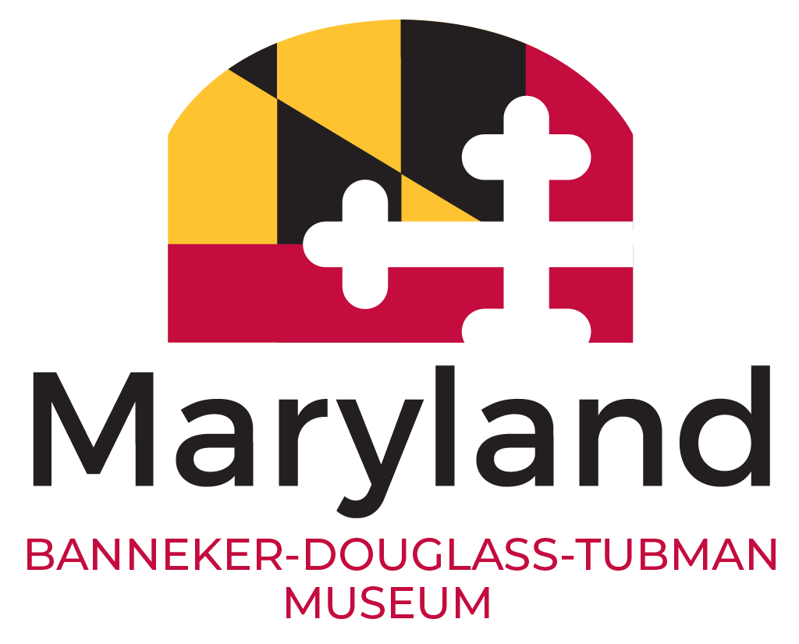
Banneker-Douglass-Tubman Museum
VOLUNTEER/GALLERY GUIDE APPLICATION
The Banneker‐Douglass-Tubman Museum Volunteer and Gallery Guide Programs are designed to enhance the daily activities of the museum, assist the BDTM staff with their endeavors as well as be active by participating in museum events. This is accomplished by volunteers sharing their gifts and talents in assisting with the presentation of educational, historical, facts of African-American ancestry to the citizens of the community through the museum.

Personal Information
Name: Phone Number:
Address:

City/State/Zip:___________________________________________________________________________________
Do you verify that you are over the age of 14?: Email address:______________________________

Area of Interest
Gallery Guides: Provide daily interactive tours to the general public and school groups. Provide interpretation of the Museum’s wealth of exhibits and information.  Library Assistant: Help keep our holdings organized and accessible with such projects as updating the catalog, maintaining the vertical file, or digitizing delicate materials.  Archives Assistant: Help to preserve and improve access to historical documents & photographs by creating descriptive inventories of selected collections.  Library Publicity: Help to promote our collection by assisting with the production of access/publicity. Tools, such as the library newsletter, book marks, and annotated bibliographies.  Program Assistant: Don’t have much time to volunteer? Assist with planning and providing public programs at the museum and locations throughout Maryland during the year. | Curatorial Assistant: Assist with researching and cataloging objects in the BDTM museum collection and potential donations to the collection. Work involves photographing objects and creating digitized images for collection database.  Office Work Assistant: Provide clerical within the BDTM. Work involves organizing materials, file, data entry, and assist in any duties needed to streamline workflow such as manage front desk.  Outreach Assistant: Help promote BDTM by assisting with the production and dissemination of marketing tools, with projects ranging from graphic design, flyer distribution, and social media.  General Museum Assistant: Interested in opportunities beyond what’s listed? Contact us and we’ll share the various duties that are available.

Days/Hours available to work: | Skills:
No Pref. _____ Monday _____

Tuesday _____ Wednesday _____
Thursday _____ Friday _____
Saturday _____ Sunday _____

Banneker‐Douglass-Tubman Museum | 84 Franklin Street | Annapolis, Maryland 21401 | 410.216.6180 | bdtmuseum.maryland.gov

Previous Employment and Volunteer History

Employment History

Company Name:_________________________________________________________________

Title:_________________________________ From:______________ To:_________________

Company Name:_________________________________________________________________

Title:_________________________________ From:______________ To:_________________

Volunteer History

Organization:

Title:

Duties: _________________________________________________________________________________
Dates:

Organization:

Title:

Duties: _________________________________________________________________________________
Dates:

Brief Replies
Why do you wish to volunteer at Banneker‐Douglass-Tubman Museum?

What do you think qualifies you best to be a BDTM volunteer?

What else would you like us to know?

Banneker‐Douglass-Tubman Museum | 84 Franklin Street | Annapolis, Maryland 21401 | 410.216.6180 | bdtmuseum.maryland.gov

sReferences

Name: Phone Number:

Email address:

Relationship:

Name: Phone Number:

Email address:

Relationship:

Emergency Contact

Name:

Telephone: ____________________________

Relationship: ___________________________

Have

you

ever

been

convicted

of

any

crime

other

than

a

minor

traffic

violation?

Yes

No

If yes, please explain: __________________________________________________________
I certify that all the information on this application is accurate and complete to the best of my knowledge and understand that misleading or false statements will constitute sufficient cause for refusal of hire or termination of my services.
As a volunteer, I understand that I am subject to a background check and authorize the State of Maryland to investigate information concerning my education, employment experience, criminal record and all other aspects of my background relevant to the position.
Additionally, I authorize the release of this information by the appropriate agencies to the investigative service.
Signature of Applicant: Date:

Please return the completed application to the Education Coordinator by mail or email to the contact information listed below.
Mail: Banneker‐Douglass-Tubman Museum | 84 Franklin Street | Annapolis, Maryland 21401
Email: bannekerdouglassmuseum@gmail.com

Banneker‐Douglass-Tubman Museum | 84 Franklin Street | Annapolis, Maryland 21401 | 410.216.6180 | bdtmuseum.maryland.gov

